CHAPTER - III INDUSTRY PROFILE
& COMPANY PROFILE

INDUSTRY PROFILE

Introduction to the Financial Services Industry
The financial services industry plays a crucial role in the economic development of a country by facilitating the flow of funds between savers and borrowers. It includes banks, non-banking financial companies (NBFCs), insurance firms, and capital market participants.
Sammaan Capital Limited operates as a Non-Banking Financial Company (NBFC), providing a wide range of financial services such as housing finance, personal loans, MSME loans, and other credit facilities. NBFCs have gained significant importance in India by catering to underserved and unbanked segments of the population.
The growth of NBFCs is driven by increasing credit demand, digital transformation, and supportive government policies.

Concept of Equity Investment
Equity investment refers to investing in shares of a company, which represents ownership in that organization. Shareholders are entitled to a portion of the company’s profits and assets.
Returns from equity investments are generated in two ways:
- Capital Appreciation: Increase in the market price of shares
- Dividends: Distribution of profits to shareholders
Equity investments are considered high-risk but also offer higher returns compared to traditional investment options like fixed deposits.

Initial Public Offering (IPO)
An Initial Public Offering (IPO) is the process through which a company offers its shares to the public for the first time. Companies use IPOs to raise capital for expansion, debt repayment, or business development.
After the IPO, shares are traded on stock exchanges, where their prices fluctuate based on market demand and supply. Companies may also issue additional shares later through secondary offerings to raise further capital.

Types of Stocks
Stocks can be classified based on their characteristics and investment objectives:

Growth Stocks
These are shares of companies that reinvest profits into expansion rather than paying dividends. They offer high growth potential but involve higher risk.

Value Stocks
These stocks are undervalued compared to their intrinsic worth. Investors expect their prices to rise over time.

Income Stocks
These provide regular dividends and are suitable for investors seeking steady income.

Blue-Chip Stocks
Shares of well-established companies with strong financial performance and stability.

Market Capitalization
Market capitalization represents the total value of a company in the stock market and is calculated as:
Market Capitalization = Share Price × Number of Outstanding Shares
Companies are categorized into:
- Large-cap companies: Stable and less risky
- Mid-cap companies: Moderate growth potential
- Small-cap companies: High growth with higher risk
Market capitalization helps investors understand the size and risk profile of a company.

Price-to-Earnings (P/E) Ratio
The Price-to-Earnings (P/E) ratio is an important indicator used to evaluate a company’s valuation.
- High P/E Ratio: Indicates growth expectations
- Low P/E Ratio: May indicate undervaluation or weak performance
Investors use the P/E ratio to compare companies within the same industry.

Factors Affecting Stock Prices
Stock prices are influenced by various factors:

Investor Demand
When demand for a stock increases, its price rises. When demand decreases, the price falls.

Company Performance
Strong financial performance leads to higher stock prices, while poor performance results in price decline.

Economic Conditions
Inflation, interest rates, and government policies impact stock market performance.

Market Sentiment
Investor expectations and emotions also play a significant role in determining stock prices.

Dividends and Shareholder Returns
Dividends are a portion of profits distributed to shareholders. Companies with consistent dividend payments are considered financially stable.
An increase in dividends signals strong financial health, while a decrease may negatively impact investor confidence.

Earnings and Financial Performance
A company’s earnings are a key determinant of its stock price. Investors analyze:
- Revenue growth
- Profit margins
- Return on equity
Higher earnings generally lead to increased investor confidence and higher stock prices.

Intrinsic Value of Shares
Intrinsic value refers to the true value of a company based on its fundamentals and future earning potential. It helps investors determine whether a stock is:
- Undervalued
- Fairly valued
- Overvalued
This concept is essential for long-term investment decisions.

Stock Splits
A stock split is a corporate action where a company increases the number of shares while reducing the price per share.
For example, in a 2-for-1 split:
- Number of shares doubles
- Price per share is halved
The total investment value remains unchanged initially, but it improves liquidity and attracts more investors.

Stock Research and Evaluation
Before investing, investors must analyze the company thoroughly. Key sources of information include:
- Annual reports
- Financial statements
- Market trends
- Industry analysis
For Sammaan Capital, important evaluation factors include loan portfolio quality, asset management, and growth strategy.

Buying and Selling of Shares
Shares can be traded through different channels:

Full-Service Brokers
Provide advisory services along with trading facilities.

Discount Brokers
Offer low-cost trading with limited services.

Online Trading Platforms
Allow investors to trade conveniently with minimal cost and real-time access.
Online trading has become the most popular method due to its speed and cost efficiency.

Volatility in the Stock Market
Volatility refers to the rate at which stock prices increase or decrease over time. High volatility indicates higher risk and potential returns.
Factors causing volatility include:
- Economic changes
- Market sentiment
- Company-specific news

Risk Management in Equity Investment
Risk is an inherent part of stock market investment. Effective risk management strategies include:
- Diversification of portfolio
- Long-term investment approach
- Asset allocation
- Setting realistic financial goals
Proper risk management helps investors minimize losses and maximize returns.

Indian Stock Market Scenario
The Indian stock market has shown significant growth over the years due to:
- Economic reforms
- Increased foreign investments
- Growth in corporate earnings
- Digitalization of financial services
Financial institutions like Sammaan Capital contribute to this growth by providing credit and financial solutions to individuals and businesses.

Role of Sammaan Capital in the Industry
Sammaan Capital Limited plays an important role in the Indian financial ecosystem by:
- Providing housing finance and retail loans
- Supporting MSMEs with credit facilities
- Expanding financial inclusion
- Strengthening the NBFC sector
The company’s transition into a diversified NBFC reflects its commitment to growth and innovation.

COMPANY PROFILE
Introduction to Sammaan Capital

The India bulls Group has undergone significant transformation and restructuring in recent years, with its flagship company, India bulls Housing Finance Ltd., being rebranded as Sammaan Capital Limited in 2024. As of 2026, the company operates as a mortgage-focused Non-Banking Financial Company (NBFC) under the regulatory framework of the Reserve Bank of India (RBI). It has built a strong presence in the housing finance segment, with a balance sheet of around ₹70,000 crore and a customer base exceeding 1.6 million across India.

The company’s market capitalization is currently in the range of ₹11,000–12,000 crore, reflecting changes in its financial positioning over time. It is rated ‘AA/Stable’ by leading credit rating agencies, indicating a stable but moderate level of credit strength compared to its earlier ‘AAA’ status. Unlike its earlier position, the company is no longer a constituent of the NIFTY50 index.

Strategically, Sammaan Capital has shifted its focus toward affordable housing finance, loan against property, and the expansion of its retail and MSME lending portfolio. This shift aligns with the growing demand for housing and credit accessibility in India. Additionally, the company has attracted significant investment from global investors, which is expected to support its growth plans, enhance operational capabilities, and strengthen its overall position in the Indian financial services industry.

BOARD OF DIRECTORS
Sammaan Capital Limited

Mr. Subhash Sheoratan Mundra

Chairman

Mr. Gagan Banga

Managing Director & CEO

Mr. Sachin Chaudhary
Whole-time Director / COO

Mr. Achuthan Siddharth

Independent Director

Mr.Dinabandhu Mohapatra

Independent Director

Mr.Shefali Shah

Independent Director

Mr.Rajiv Gupta

Nominee Director

Equinox India Developments Limited

Mr.Sameer Gehlaut
Chairman
Mr.Gagan Banga
Executive Vice Chairman
Mr.Ashok Kumar Gupta
Joint MD
360 ONE WAM Limited
Mr. Karan Bhagat Executive Director & CEO Mr.Yatin Shah
Executive Director
Mr.Gagan Banga Director
Mr.Ashok Kumar Gupta Independent director

Mr.Kamlesh Chakrabarty Independent Director Mr.Shamsher Singh Ahlawat Independent Director

MILESTONES

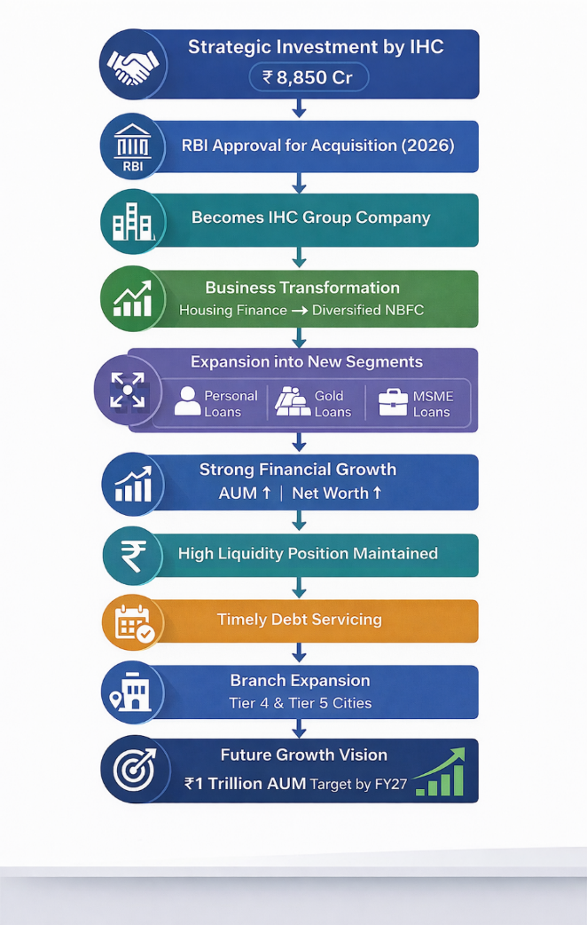

Sammaan Capital Limited Supports Moneylife Foundation in Empowering Investors

Sammaan Capital Limited, in association with Moneylife Foundation, played a vital role in organizing the “Investor, Empower Yourself” seminar held on 7th May 2017 at the Town & Country Club. The event took place in New Gurgaon, part of the National Capital Region (NCR), and marked a significant step in extending investor awareness initiatives beyond Maharashtra, where Moneylife Foundation had primarily been active.
The seminar highlighted Sammaan Capital Limited’s strong commitment to promoting financial literacy and empowering investors. With participation from more than 300 attendees, the event attracted individuals from Gurgaon, Delhi, and various parts of North India, including Allahabad, Ludhiana, and Chandigarh. The large turnout reflected a growing interest among individuals in understanding financial planning and making informed investment decisions.
The program began with an introductory address by Gagan Banga, Vice Chairman and Managing Director of Sammaan Capital Limited. He emphasized the importance of financial education in today’s dynamic economic environment. This was followed by an introduction to Moneylife Foundation by Veeresh Malik, who outlined the organization’s mission of enhancing financial awareness and protecting investor interests.
The seminar featured insightful sessions conducted by well-known experts. Sucheta Dalal, Trustee of Moneylife Foundation, guided participants on safeguarding their finances and avoiding common financial mistakes. Debashis Basu, also a Trustee and Editor of Moneylife, delivered an engaging session on making smart and well-informed investment decisions. Their sessions, supported by practical examples, were beneficial for both experienced investors and beginners.
Adding further value, Sachin Choudhary, Director and Business Head at Sammaan Capital Limited, shared important insights into housing finance. He explained key do’s and don’ts of mortgage borrowing, helping participants understand responsible borrowing practices. Additionally, Sucheta Dalal highlighted the importance of wills and nominations, stressing the need for proper financial planning and secure wealth transfer.
An interactive panel discussion formed a key highlight of the event, featuring Sucheta Dalal, Debashis Basu, and Sachin Choudhary. The discussion covered important topics such as investment strategies, risk management, and financial planning. Participants actively engaged in the session by asking relevant questions, which were effectively addressed by the panel, making it both informative and interactive.
The primary objective of the seminar was to enhance awareness and equip individuals with the knowledge required to make sound financial decisions. The event successfully catered to a diverse audience, ranging from financially aware individuals to beginners. By simplifying complex financial concepts, the seminar helped bridge the knowledge gap and encouraged responsible investment behavior.
The event concluded with a vote of thanks by Monu Ratra, National Sales Manager at Sammaan Capital Limited. He expressed appreciation to the speakers, organizers, and participants for contributing to the success of the seminar. The initiative received positive feedback, with many attendees expressing interest in similar programs in the future.
Participants also suggested expanding such seminars to different cities across India and recommended live telecasts through digital and television platforms to reach a wider audience. These suggestions reflect the increasing demand for accessible financial education.
Moneylife Foundation continues to play a crucial role in promoting financial literacy and advocating investor rights across India by organizing workshops and awareness programs. In line with this vision, Sammaan Capital Limited actively engages in corporate social responsibility initiatives aimed at educating investors and promoting transparency. Through such efforts, the company contributes to building a financially informed society, supporting sustainable economic growth and development.

THE HUB

Sammaan Capital Limited has developed The Hub, a modern and intelligently designed business centre located at One Indiabulls Centre. This initiative reflects the company’s forward-looking approach to providing innovative workspace solutions aligned with evolving business needs.
With the growing demand for flexible and cost-effective office spaces in India, The Hub caters to a wide range of businesses, including startups, SMEs, and large corporations. It offers around 25,000 sq. ft. of fully serviced office space with flexible configurations, enabling organizations to choose setups based on their size and requirements.
The Hub provides a premium working environment supported by modern amenities such as security, maintenance, pantry services, and efficient management of utilities. It is equipped with advanced IT and telecom infrastructure, meeting rooms, video conferencing facilities, and professional reception services, ensuring smooth business operations.
Located in Lower Parel, a prime commercial area, The Hub enjoys excellent connectivity to key business districts like Nariman Point and Bandra Kurla Complex. Its strategic location, along with premium facilities, makes it an attractive workspace solution.
Overall, The Hub represents a blend of flexibility, convenience, and modern infrastructure, supporting businesses in achieving productivity and growth.

Sammaan Capital Limited CSR Initiative – Drug Access Program

Sammaan Capital Limited, as part of its corporate social responsibility (CSR) efforts, has undertaken a meaningful healthcare initiative by supporting a Drug Access Program for cancer patients in collaboration with Novartis.
Recognizing that cancer treatment is often expensive and unaffordable for many, especially economically weaker sections, the company partnered with Novartis to provide access to essential life-saving medicines. Under this program, eligible patients receive subsidized or free drugs based on their financial condition, ensuring continuity in treatment and improving recovery outcomes.
Beyond medication support, the initiative also focuses on patient awareness, counseling, and guidance throughout the treatment process. By working with healthcare providers, the program ensures that patients receive proper information on treatment, medication usage, and follow-up care.
This collaboration highlights the importance of public-private partnerships in addressing healthcare challenges in India. It has helped reduce the financial burden on patients and improved access to quality treatment.
Overall, the Drug Access Program reflects Sammaan Capital Limited’s commitment to social responsibility and its vision of creating a positive impact by promoting healthcare accessibility and community well-being.

NOA program

Sammaan Capital Limited, under its Corporate Social Responsibility (CSR) initiatives, supports healthcare programs that improve access to life-saving treatments. One such initiative is its association with the Novartis Oncology Access Program, in collaboration with Novartis.
The NOA Program is a global effort aimed at making advanced cancer medicines affordable and accessible in low- and middle-income countries like India. Since cancer treatment is often expensive, the program provides high-quality oncology drugs at significantly reduced costs, helping patients continue their treatment without financial strain.
Through this initiative, Sammaan Capital Limited supports patients by ensuring timely access to essential medicines, improving treatment outcomes and survival rates. The program focuses on affordability, continuity of care, and reducing the financial burden on patients and their families.
Additionally, it promotes patient awareness and guidance by working closely with hospitals and healthcare professionals, ensuring proper understanding and adherence to treatment.
Overall, Sammaan Capital Limited’s involvement in the NOA Program reflects its commitment to healthcare accessibility and social welfare, contributing to a more inclusive and supportive healthcare system.

Sammaan Capital Foundation

Sammaan Capital Limited, through the Sammaan Capital Foundation, actively works towards addressing key development challenges in India. While the country has achieved strong economic growth, improved infrastructure, and better access to education, significant socio-economic disparities still exist.
Many communities, particularly in rural areas, continue to face challenges such as poverty, lack of quality healthcare, inadequate sanitation, and limited access to clean water and electricity. Issues like malnutrition, infant mortality, gender inequality, and poor education quality further hinder inclusive development.
Recognizing this gap between growth and ground realities, Sammaan Capital Foundation focuses on promoting inclusive and sustainable development. Its initiatives are centered on key areas such as education, healthcare, livelihood development, and basic infrastructure support.
Through these efforts, the foundation aims to uplift underserved communities and ensure that the benefits of economic progress reach all sections of society. Overall, Sammaan Capital Limited remains committed to contributing to nation-building by fostering equality, social well-being, and long-term sustainable development.

Commercial Vehicle Loans – Sammaan Capital Limited
Sammaan Capital Limited offers Commercial Vehicle Loans tailored to support both first-time buyers and established fleet operators. The company is recognized for providing quick, transparent, and hassle-free financing solutions that cater to the evolving needs of the transportation sector.
These loans are designed to help small and medium transport operators acquire vehicles with minimal documentation and easy procedures. With strong industry knowledge and customer relationships, Sammaan Capital ensures efficient processing and customized financial solutions.

1. Product Offerings
The company provides a range of financing options, including:
- New Commercial Vehicle Loans
- Used Commercial Vehicle Loans
- Tractor Loans
These products serve diverse customers, from individual operators to large logistics businesses.

2. Additional Financing Options
To enhance flexibility, Sammaan Capital also offers:
- Tyre Funding
- Accidental Repair Funding
- Engine Funding
- Takeover Loans (Balance Transfer)
- Top-up Loans on existing loans
These options help customers manage operational and maintenance expenses effectively.

3. Key Features
The loan offerings are designed to be flexible and customer-friendly, with:
- Financing for vehicles up to 15 years old
- Up to 95% funding for used vehicles and 100% for new chassis
- Loan tenure up to 48 months (used vehicles) and 60 months (new vehicles)
- Customized repayment options
- Simple documentation and doorstep service
- Quick approvals and disbursement
- Competitive interest rates
- Transparent processing without intermediaries

Organization Structure- Board of Directors:

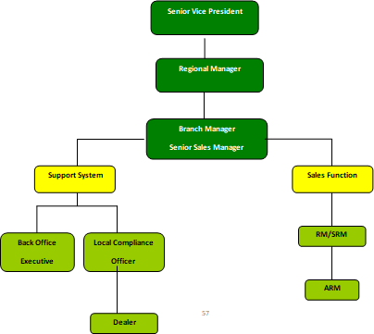

Trading Products of Indiabulls Securities

Trading Accounts
│
────────────────── ┼──────────────────
│ │ │
Cash Account Intraday Account Margin Trading (Mantra)
│ │ │
Delivery-based Same-day buy & Trade using leverage
trading sell trading (borrowed funds)
Sammaan Capital Limited offers different types of trading accounts to cater to the diverse needs of investors and traders:
- Cash Account:
This account is used for delivery-based trading, where investors purchase shares and hold them for a longer period. It is suitable for long-term investors who aim for capital appreciation and dividends.
- Intraday Account:
This account is meant for traders who buy and sell securities within the same trading day. It helps investors take advantage of short-term price movements in the market.
- Margin Trading (Mantra):
This facility allows investors to trade with borrowed funds (leverage), enabling them to take larger positions in the market with limited capital. It is suitable for experienced traders looking for higher returns, though it involves higher risk.

The subsidiaries of Sammaan Capital Financial Services Ltd. include:

- Indiabulls Housing Finance Limited
- Indiabulls Commercial Credit Limited
- Indiabulls Asset Management Company Limited
- Indiabulls Securities Limited

Projects Pipeline

  - BLU, Worli, Mumbai – 7‐Star luxury residential complex spread over 10 acres in South Mumbai with breathtaking sea views
  - IB Golf City, Savroli, MMR – Premium residential township with 18‐hole golf course spread over 350 acres of greens1 IB City Sonepat Haryana 150 Acres of integrated township with plotted development commercial City, Sonepat, – development, and group housing
  - IB Enigma II, Sec 104, Gurgaon – Super premium residential complex with Villa’s and high rise towers spread over 34 acres
  - IB Imperial, Sec 106, Gurgaon – 54 Acres of Integrated township with high end residential apartments, villa’s, luxury retail and commercial
  - IB Commercial Centre, Sec 109, Gurgaon – Over 5 acres of commercial development on the Dwarka Expressway

  - IB Greens, Chennai – Premium residential township with high rise towers near the IT corridor spreadover 32 acres
  - IB Mint, Sec 104, Gurgaon – Iconic Commercial tower on the Dwarka Expressway
  - IB Greens, Indore ‐ 15 Acres of Integrated township with high end residential apartments, retail andcommercial in the heart of the city
  - IB Mega Mall, Agra & Kanpur – Destination mall/multiplex in the heart of the city

Bankers of Sammaan Capital Financial Services Ltd.
Sammaan Capital Financial Services Ltd. maintains strong relationships with leading banks to support its financial operations, funding requirements, and business growth. The key banking partners include:
- HDFC Bank
- ICICI Bank
- Axis Bank
- State Bank of India
- Kotak Mahindra Bank
- Yes Bank

OUR BUSINESSES
Sammaan Capital Limited operates across multiple segments of the financial and allied industries, offering a diversified range of products and services. The company’s key business verticals include:

Home Loans
Sammaan Capital provides housing finance solutions to individuals for purchasing, constructing, or renovating residential properties. These loans are designed with flexible repayment options and competitive interest rates.

Personal Loans
The company offers unsecured personal loans to meet various financial needs such as education, medical expenses, travel, or other personal requirements, with quick approval and minimal documentation.

Loan Against Property (LAP)
Sammaan Capital provides loans against residential or commercial property, enabling customers to unlock the value of their assets while retaining ownership.

Business Loans
The company supports entrepreneurs and enterprises by offering business loans to meet working capital needs, expansion plans, and operational requirements, especially for MSMEs.

Asset Management
Through its asset management services, Sammaan Capital facilitates investment solutions such as mutual funds and portfolio management, helping clients grow their wealth efficiently.

Securities & Investment Services
Sammaan Capital offers trading and investment services, enabling customers to participate in equity markets, derivatives, and other financial instruments.

Real Estate Development
The company is involved in real estate projects, including residential, commercial, and integrated townships, contributing to urban infrastructure development.

